CIS 61 :: Lab 03 - Higher Order Functions - Template
[DO NOT USE RECURSION, FOR LOOP or LISTS IN ANY OF YOUR SOLUTIONS]

Student Name:
Question 1: Lambdas and Currying

Write a function lambda_curry2 that will curry any two argument functions using lambdas. See the doctest or refer to the textbook if you're not sure what this means.
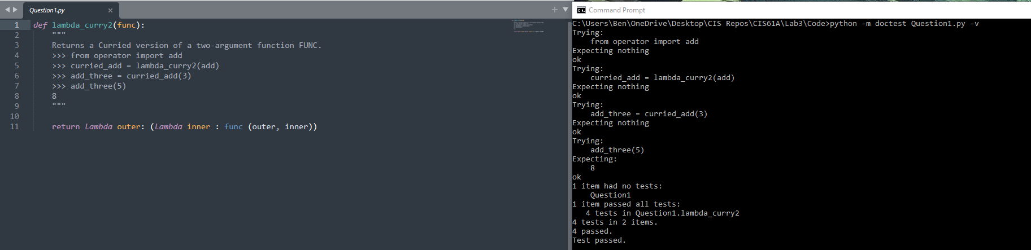

Question 2: Write a function that takes in a function cond and a number n and prints numbers from 1 to n where calling cond on that number returns True.
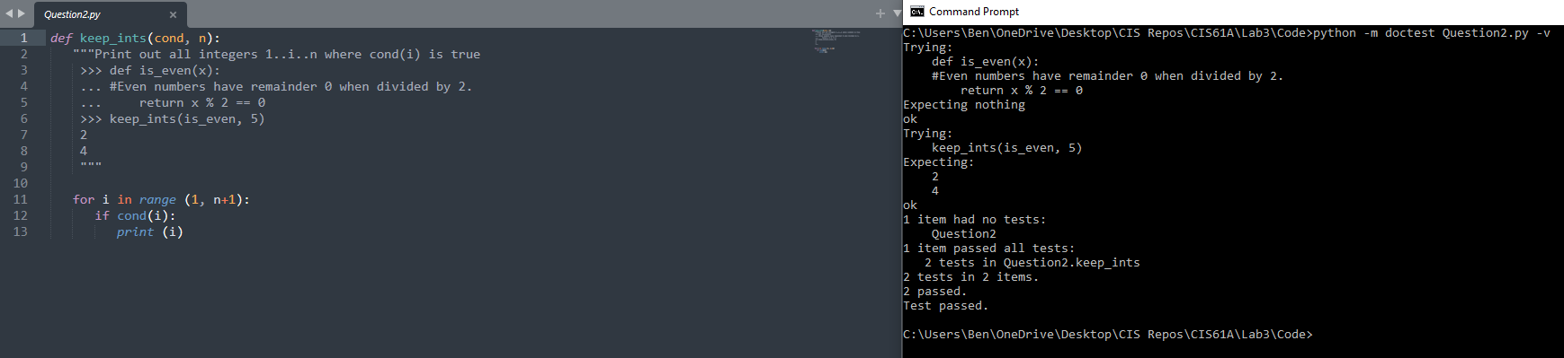

Question 3: Write a function similar to keep_ints like before, but now it takes in a number n and returns a function that has one parameter cond. The returned function prints out numbers from 1 to n where calling cond on that number returns True.
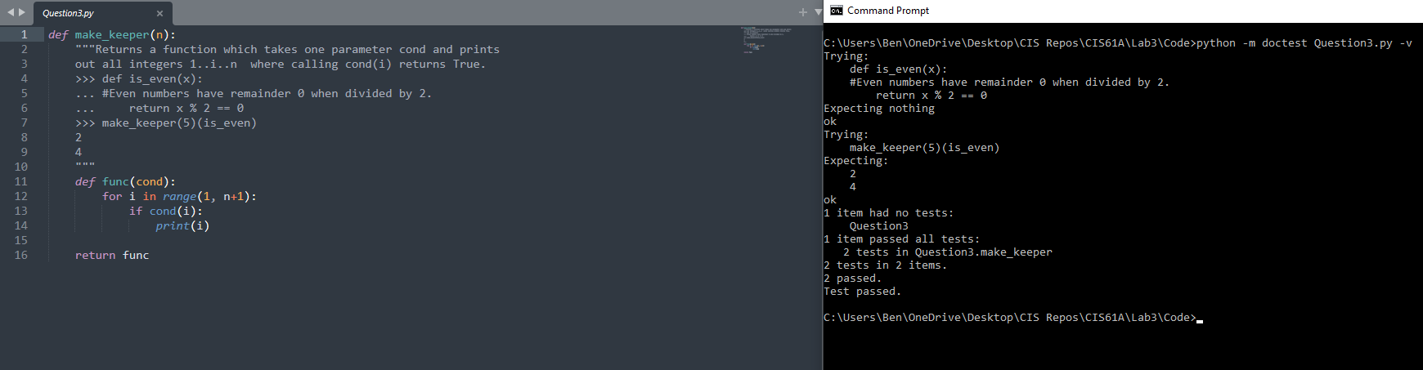

Question 4: Write a function and_add that takes a one-argument function f and a number n as arguments. It should return a function that takes one argument, and does the same thing as the function f, except also adds n to the result.
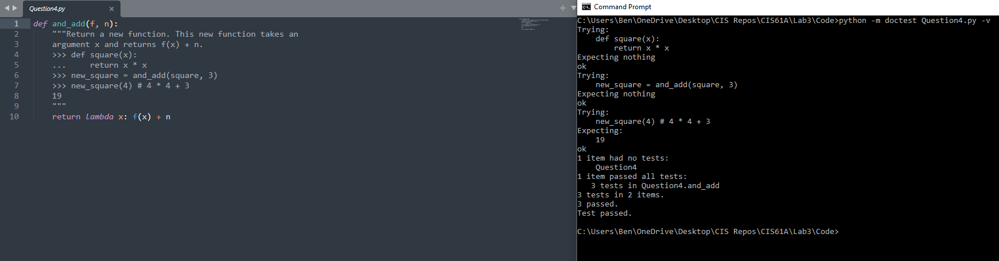

Question 5 - Draw an environment diagram for the following code and predict what Python will output. You need to do these problems on paper to develop familiarity with Environment Diagrams. Scan or take a picture of your solution and paste here.
